Henri, Robert (1865-1929)

Robert Henri (born Robert Henry Cozad in Ohio) is best known as the leader of the Ashcan School, a group of Realist painters who portrayed New York City life in the first decades of the twentieth century. His works ranged from tonalist landscapes, to full-length portraits of socialites and performers, to an extensive series of ordinary people from different cultures, many of them children. At the Pennsylvania Academy of the Fine Arts in 1886, Henri adopted a Realist style, which he honed in Paris at the Academie Julian. Back in Philadelphia, he taught at local art schools and in 1892 formed the Charcoal Club. This informal weekly discussion and sketching session included John Sloan and other local newspaper illustrators, who Henri encouraged to become painters of contemporary life. Henri studied the works of Diego Velázquez, Rembrandt, and Frans Hals on several more European trips. In 1900 he settled in New York with his wife Linda Craige (c. 1875-1905). Henri’s early works included small landscapes influenced by Whistlerian tonalism, such as La Neige (1899). He established his career, however, as a painter of large-scale figure paintings. He was invited to join the Society of American Artists and the National Academy of Design in 1903 and 1905, respectively.

In 1908 Herni and Sloan organized the groundbreaking show of ‘The Eight’ at New York’s Macbeth Galleries to protest the restrictive juried exhibitions of the National Academy. Henri and his circle garnered a great deal of notoriety for their ‘rebellious’ show, which opened up new exhibition opportunities for younger artists working in innovative styles. Henri was also involved in the large, unjuried Exhibition of Independent Artists (1910) and the famous International Exhibition of Modern Art (1913), more popularly known as the Armory Show, which introduced modern art to American audiences. He continued his travels throughout Europe and the American Southwest, often leading groups of art students. In these locales he sought out interesting faces to paint, executing them in a quick and lively manner. He increasingly became known for these “types”—small, intimate portraits of ordinary people, who embodied universal human values and represented specific racial or national characteristics. Following the color theories of Hardesty Maratta, in the early 1910s, Henri and his friends began experimenting with a higher-keyed palette and a fuller spectrum of colors, as exemplified by his portrait of the arts patron Gertrude Vanderbilt Whitney (1916). Throughout his career, Henri was an inspirational teacher to thousands of art students, including Edward Hopper, Rockwell Kent, and Stuart Davis. The Art Spirit, a compilation of his art and teaching philosophy, has been issued in numerous editions since its original publication in 1923, and is still required reading in many art schools.

References and further reading:

Homer, W. I.(1988) Robert Henri and His Circle. Ithaca: Cornell University Press, 1969; rev. ed. New York: Hacker Art Books.

Leeds, V. A. (1994) My People: The Portraits of Robert Henri. Orlando, FL: Orlando Museum of Art.

Perlman, B. (1991), Robert Henri: His Life and Art New York: Dover Publications.
Sloan, J. and Henri, R. (1997) Revolutionaries of Realism: The Letters of John Sloan and Robert Henri. Edited by Bennard B. Perlman. Princeton, NJ: Princeton University Press.

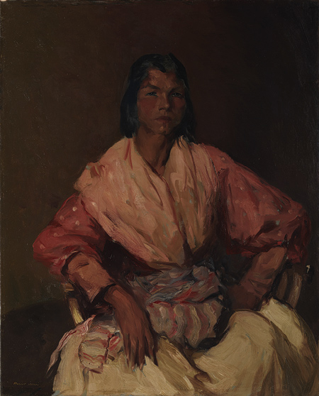
The Spanish Gypsy, 1912
Robert Henri (American, 1865–1929)
Oil on canvas; 40 3/4 x 33 in. (103.5 x 83.8 cm)
Arthur Hoppock Hearn Fund, 1914 (14.80)
http://www.metmuseum.org/toah/works-of-art/14.80

